**PASSWORD REGISTRATION AND ENCRYPTION .NET DESKTOP PROJECT**



**Developer:Pelin BİNGÖL**

**Project Advisor:Serkan DEVRİM**

**Secure Password Management App**

This project is a software that aims to enable users to create, store and manage secure passwords for various platforms. Users can use this application to use passwords that they will use for different websites, applications or services. The main goal is to minimize security risks by storing users' passwords securely and providing easy access to them.

**Technologies and Languages Used**

**Programming Language:** C# (C Sharp) programming language was used in this project. C# is a modern programming language that is preferred by a wide range of users and is reserved by Microsoft.

**Database:** The project uses SQL Server database for storing and storing passwords. SQL queries are used to access and update the database data.

**Windows Forms:** Windows Forms technology was used to create the user unit. This is a .NET Framework tool used to create Windows-based desktop applications.

**Application Functions**

- Adding and Updating Passwords: Users can use or update passwords for different platforms. Passwords are securely encrypted and stored during this process.

- Platform Search: Users can gain a comprehensive understanding of the passwords they have registered for a specific platform or service.

- De-registration: Passwords can now be deleted by the user during application runs or those that may pose security vulnerabilities.

- Encryption Algorithms: Users include different encryption programs to protect their passwords. These programs ensure that passwords work securely.

- Database Management: User information is stored in SQL Server database in the form of tables. The application contains the necessary codes for data transfer and transactions.

**Project Objective**

This project aims to help users manage their passwords more securely in the face of increasing security threats and risk of cyber-attacks in the modern digital world. Users can manage more secure passwords on various platforms by avoiding using the same or weak passwords. It also aims to provide an example for developers who want to learn C# programming language and SQL database data.

This application aims to contribute to the awareness of users in terms of security and monetary aspects and aims to facilitate the implementation of secure password management.

**Guide**

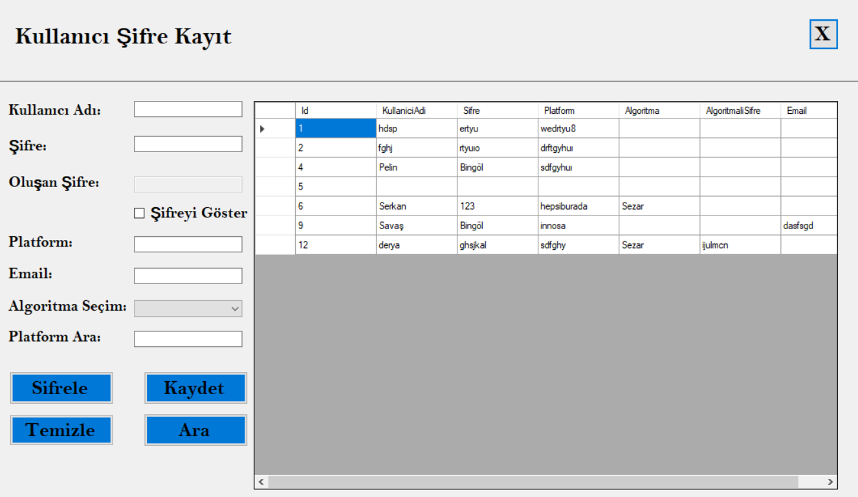

* When we enter the application, this screen will welcome us and we will fill in the relevant boxes.
  + When we click on the "*Sifrele*" button in line with the algorithm we have selected from the "*Algorithm Selection*" section, it algorithmizes the password you enter according to the selected algorithm and writes it in the password box. When we click the Save button, it saves the data. It shows it in the table.

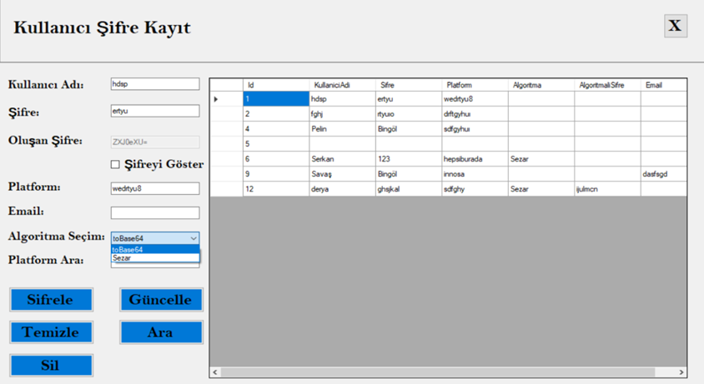

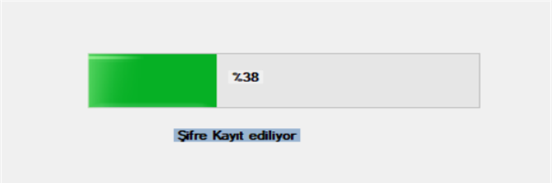

* + When we click on the "*Clear*" button, it clears the boxes.
  + When we click the "*Search*" button according to the platform name we wrote in the "*Search Platform*" box, it shows the relevant records in the table.

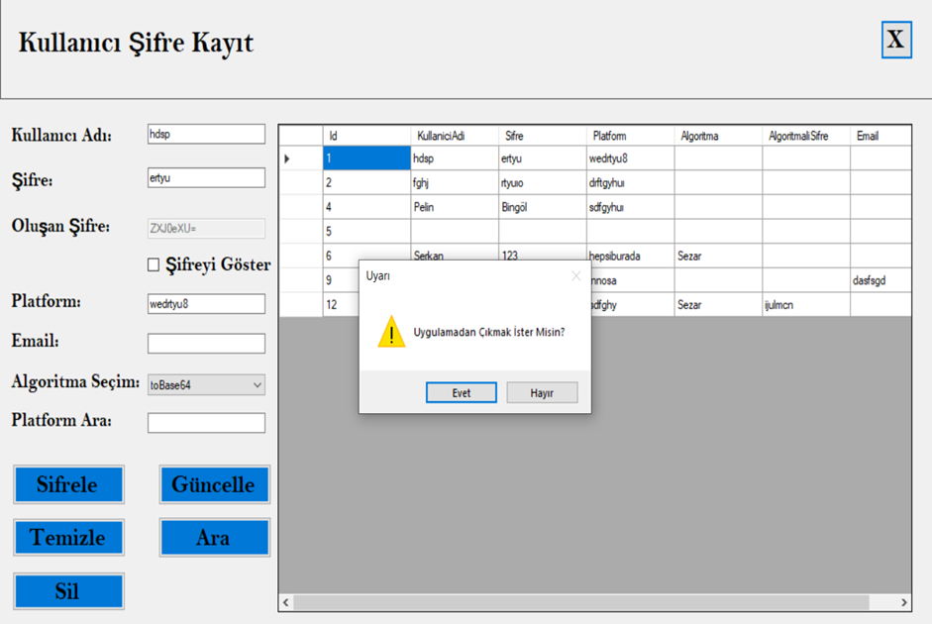

* If we click on the "*Delete*" button, the relevant data is deleted. It is shown in the table.
* When we click on the "*X*" button, the message "*Do you want to exit the application?*" appears on the screen. If we press the "*Yes*" box, we exit the application. If we press "*No*", we return to the application.